Exercise 15

1. List all employee ids and birth dates who were born before 1965.

SELECT e_id, birth_date FROM employee_per WHERE birth_date < '1965-01-01';

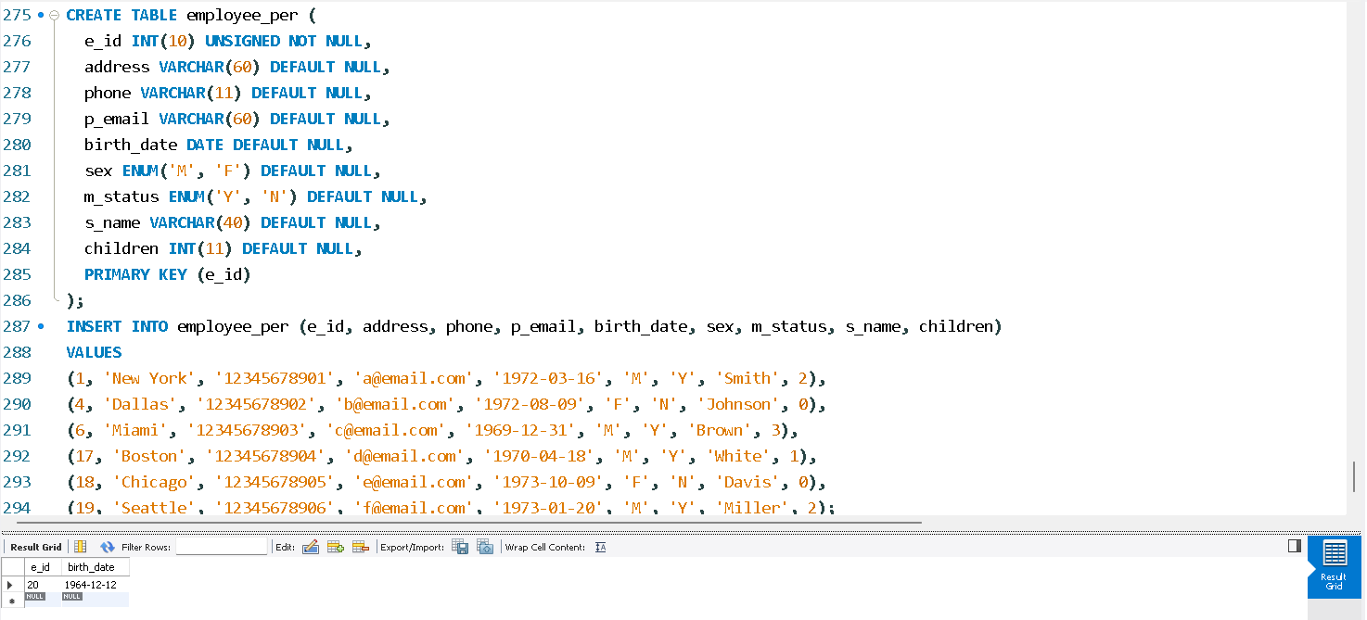

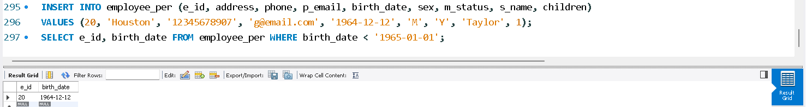

2. Display ids and birth dates of employees born in and between 1970 and 1972.

SELECT e_id, birth_date FROM employee_per WHERE birth_date >= '1970-01-01' AND birth_date <= '1972-12-31';

